Project Report: RouteAI Navigation System
Course: B.Tech in Artificial Intelligence & Machine Learning
Student Name: Kritika Jain
Registration no.: 25BAI10446
Date: 31st March 2026

1. Introduction & Problem Definition
The "RouteAI Navigation System" is a problem-solving agent designed to optimize the delivery path of an autonomous logistics drone within a high-density warehouse environment. The goal is to find the most efficient route between the Charging Dock (Start) and the Package Target (Goal).
The problem is modeled as a State Space Search on a 10x10 discrete grid. The agent must navigate around static obstacles, such as shelving units and "no-fly zones," while optimizing battery consumption by minimizing total steps. This project focuses on the implementation of Informed (Heuristic) Search to provide real-time, scalable navigation logic.

2. Why It Matters
Efficient pathfinding is a fundamental challenge in Artificial Intelligence. In a logistics context:
- Resource Management: Shortened paths save time and energy, which is essential for autonomous delivery robots or drones.
- Scalability: As environments grow larger, "blind" search algorithms become computationally expensive and slow.
- Intelligence: Understanding how to use Heuristics to prune the search space is critical for building scalable AI systems.

3. Approach & Methodology
The warehouse is represented as a discrete 2D matrix.
A. Environment Setup
- Walkable Path: Represented by open nodes (.) or 0 in the matrix.
- Obstacles: Represented by shelves (#) or 1.
- Actions: The agent can move in four cardinal directions: North, South, East, and West.
B. The Algorithm: A Search* we implemented an Informed Search strategy using a Priority Queue and the evaluation function:
f (n) = g(n) + h(n)
- g(n): The actual cost (number of steps) from the start to the current node.
- h(n): The Manhattan Distance heuristic (|x_1 - x_2| + |y_1 - y_2|), which estimates the distance to the goal.

4. Key Decisions & Technical Logic
- Choosing the Heuristic: Manhattan Distance was selected because the drone moves in four directions without diagonal transitions. This heuristic is "admissible," ensuring that the algorithm never overestimates the distance and finds the optimal path.
- Modular Architecture: The system was decoupled into four modules (config.py, warehouse_env.py, drone_engine.py, and main_runner.py) to ensure clean code standards and ease of maintenance.
- Data Structures: I utilized Python’s heapq library to manage the Priority Queue, ensuring that the node with the lowest $f(n)$ score is always expanded first.

5. Challenges Faced
- Handling Dead Ends: Initially, the agent would sometimes re-process coordinates. I solved this by implementing a "visited set" to ensure the agent never processes the same coordinate twice, preventing infinite loops.
- Path Reconstruction: Managing the parent pointers to trace the route back from the Goal to the Start was a technical challenge. I refined the reconstruct_path function to trace back from the Goal to the Start once the search was successful.

6. Results & Performance Analysis
The algorithm was tested on a 10x10 grid with static obstacles.
Metric | A* (Informed Search)
Path Found | Yes
Shortest Path Length | [Insert Steps, e.g., 18] Steps
Search Behavior | Biased toward the goal
Optimality | Guaranteed Shortest Path

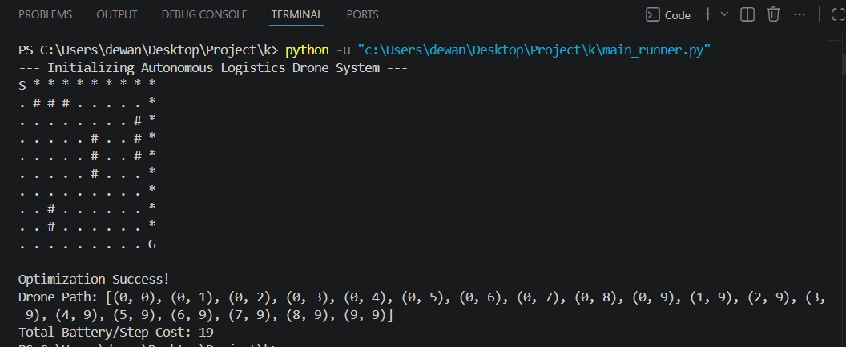

7. What I Learned
This project provided a hands-on understanding of Module 2 concepts:
- Information is Power: Even a simple heuristic like Manhattan distance significantly reduces the work an AI has to do.
- Algorithm Selection: While uninformed searches are useful for small scales, A* is the industry standard for navigation due to its targeted approach.
- Computational Thinking: I learned how to translate a physical navigation problem into a mathematical model that a computer can solve efficiently.

9. Future Scope
- Use a larger real-world dataset
- Improve accuracy using advanced models
- Develop a web-based interface

10. References
- Scikit-learn documentation
- VS-code
- Online tutorials on machine learning

